# React Native App Setup Instructions

## System Requirements

Before setting up the React Native development environment, ensure that your computer machine meets the following specifications:

* CPU: 11th Gen Intel(R) Core(TM) i7-1185G7 @ 3.00GHz 3.00 GHz
* RAM: 16.0 GB (15.8 GB usable)
* Operating System: Windows 11 Home

These specifications are based on the system used during the setup process and are recommended for optimal performance in React Native development.

## Installation Instructions

### Node.js and npm

1. Download and Install Node.js:

* Visit the Node.js website.
* Download the latest LTS version.
* Run the installer and follow the installation wizard.

1. Verify Node.js and npm installations:

* Open your terminal or command prompt.
* Run the following commands to verify the installation.

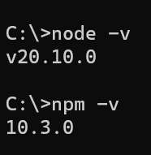

* Ensure that the displayed versions match the versions you downloaded.

### Android Studio

1. Download Android Studio:

* Obtain the executable file provided by your instructor or download it from Android Studio download page.
* Note: After clicking the file, wait for some time for the installer to run.
* Once the download is completed, run the installer and follow the on-screen instructions.
* Ensure your hard drive has enough space to accommodate the software.
* Note: You can choose not to share analytics with Google.

1. Choose Installation Type

* Choose **standard** for setting up Android Studio.
* Note: If you choose “Custom”, you can have control over the components to install and choose the Android SDK location. Ensure you have checked the following components:
  + Android SDK
  + Android API 34
  + Performance (Intel HAXM)
  + Performance (Android Emulator Hypervisor driver)
  + Android Virtual Device
* Note: If you chose “Standard”, and the default SDK location is suitable for installation.

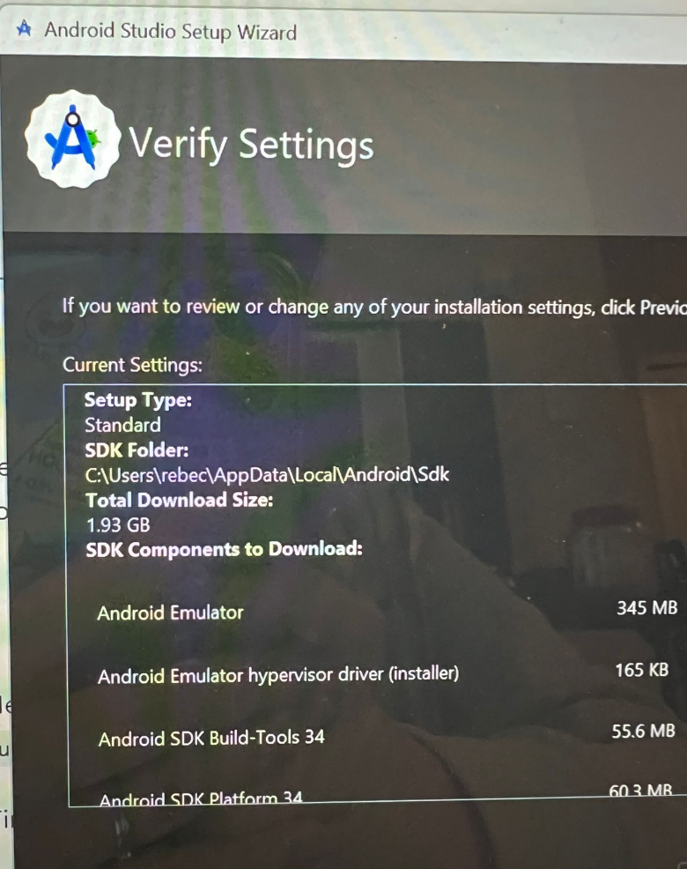

1. Accept all License Agreement as provided on-screen.
2. Finish Setup

* Once the setup is completed, Android Studio will be ready for use. However, we will not use it to create a project.

1. Verify the setup is correct:

* In the welcome screen, click “More Actions”, and select “SDK Manager.”
* In SDK Platforms, click “Show Package Details” and ensure the following components are checked:
  + Android 14.0 (“UpsideDownCake”)
    - Android SDK Platform 34
    - Sources for Android 34

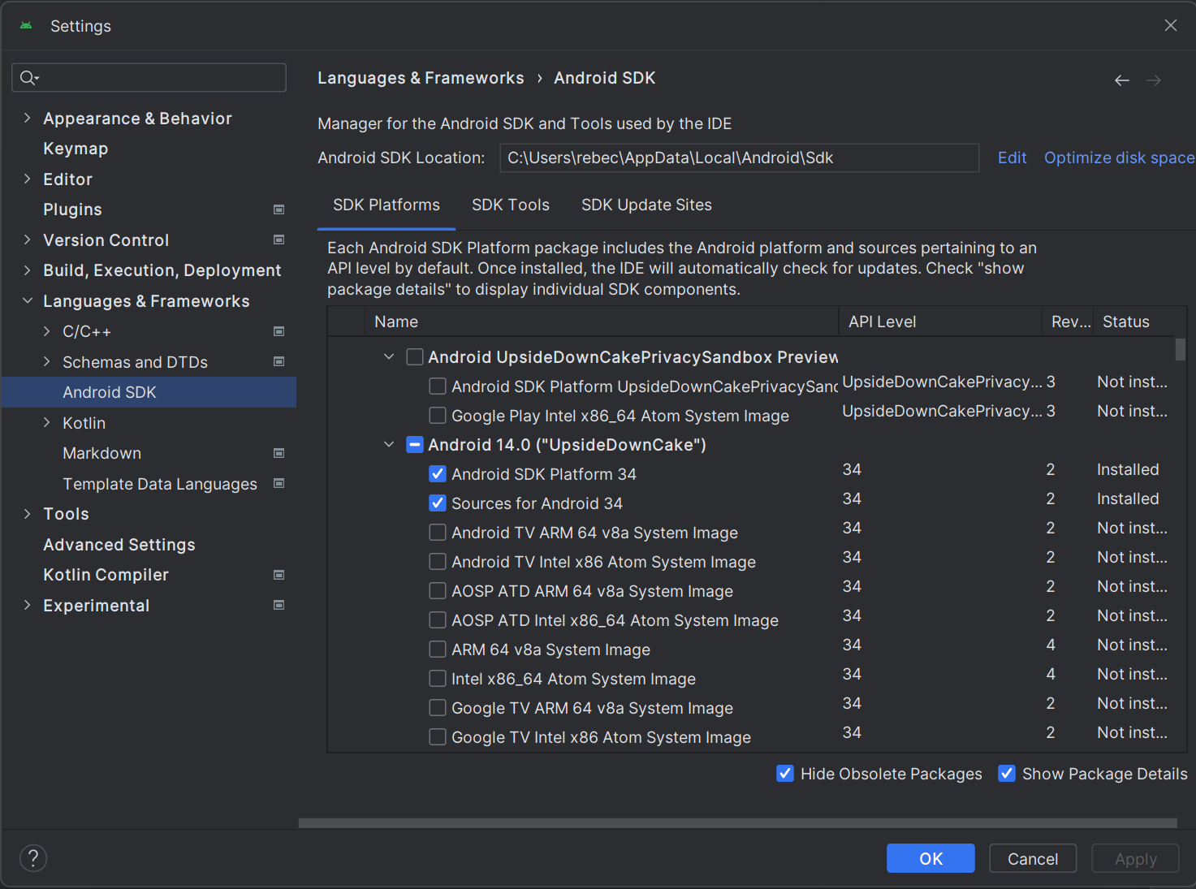

* In SDK Tools, ensure the following components are checked:
  + Android SDK Build-Tools 34
  + Android Emulator
  + Android Emulator Hypervisor driver (installer)
  + Android SDK Platform-Tools
  + Intel x86 Emulator Accelerator (HAXM installer)

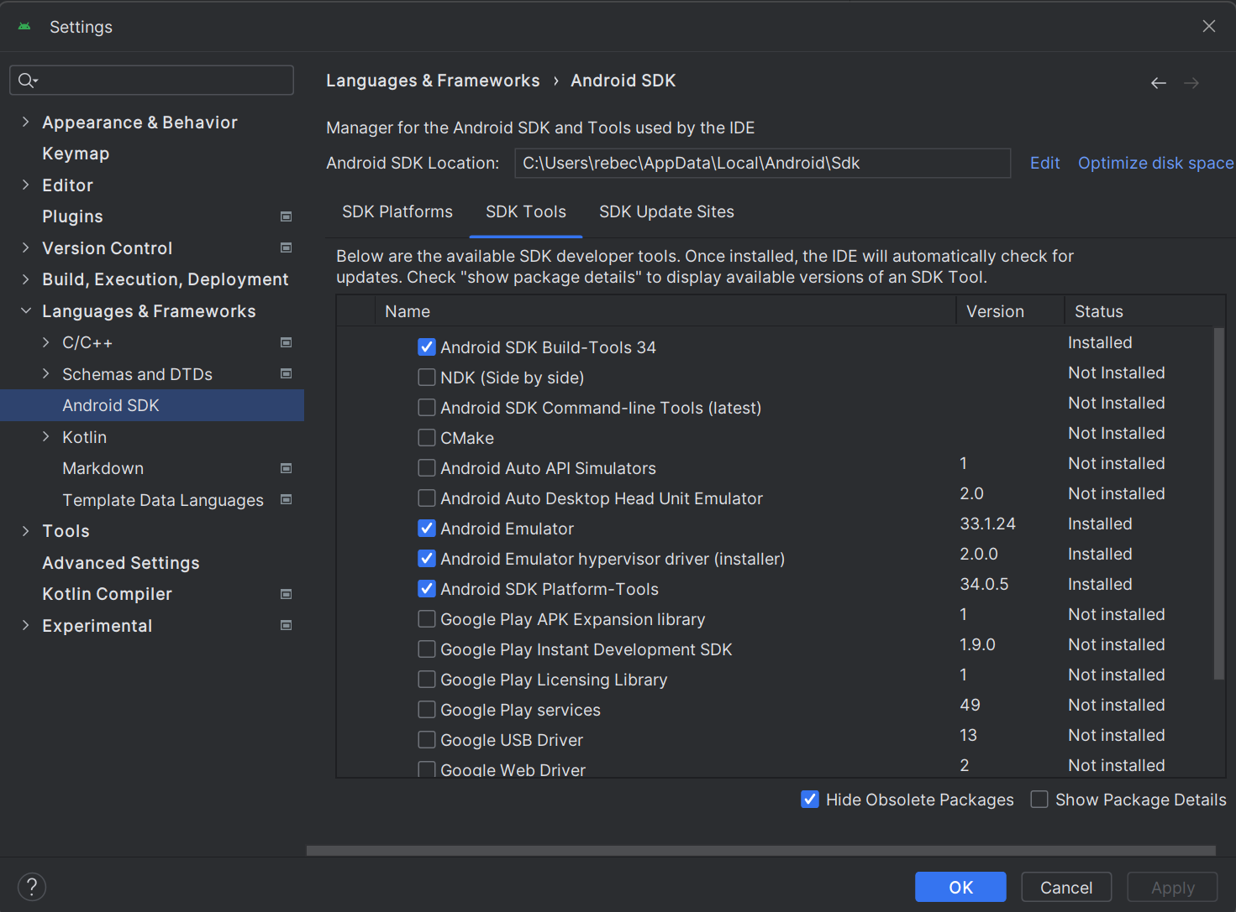

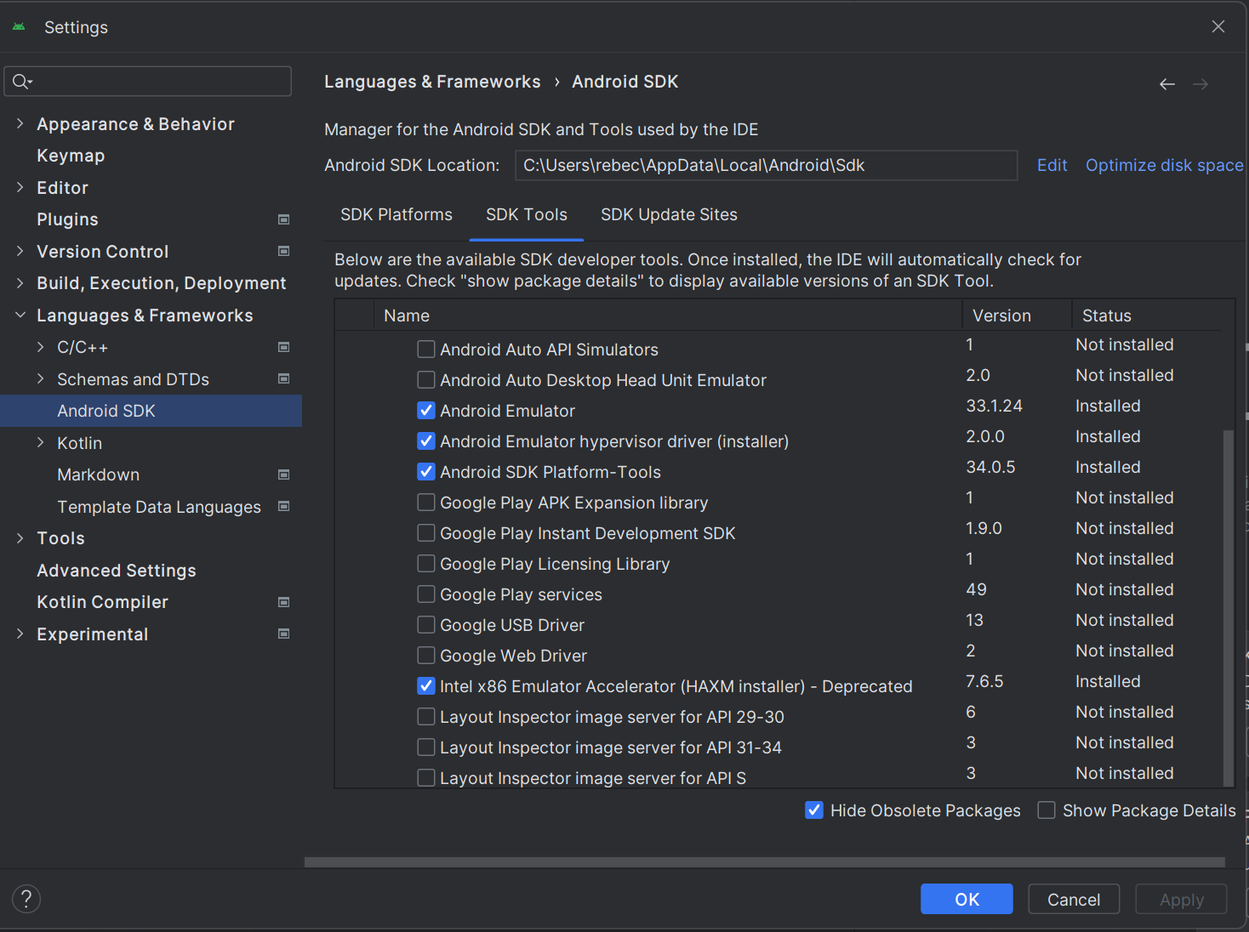

## Configuration Steps

1. Add SDK Tools to PATH:

* Open the “Environment variables” setting on your machine.
  + Type “edit environmental variable for your account” in the search bar on your computer machine.
* Click “New” to create a new ANDROID_HOME user variable that points to the path to your Android SDK:

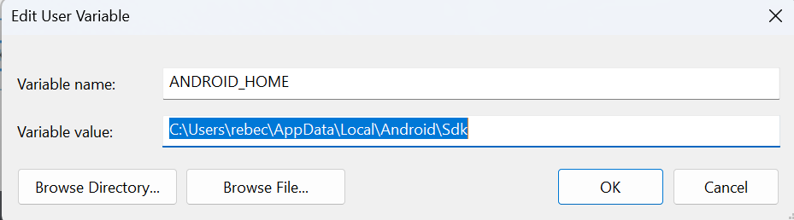

* Add Platform-tools to Path variable.
  + Click “Edit” and “Browse” to add the path to the platform-tools directory within the Android SDK installation.

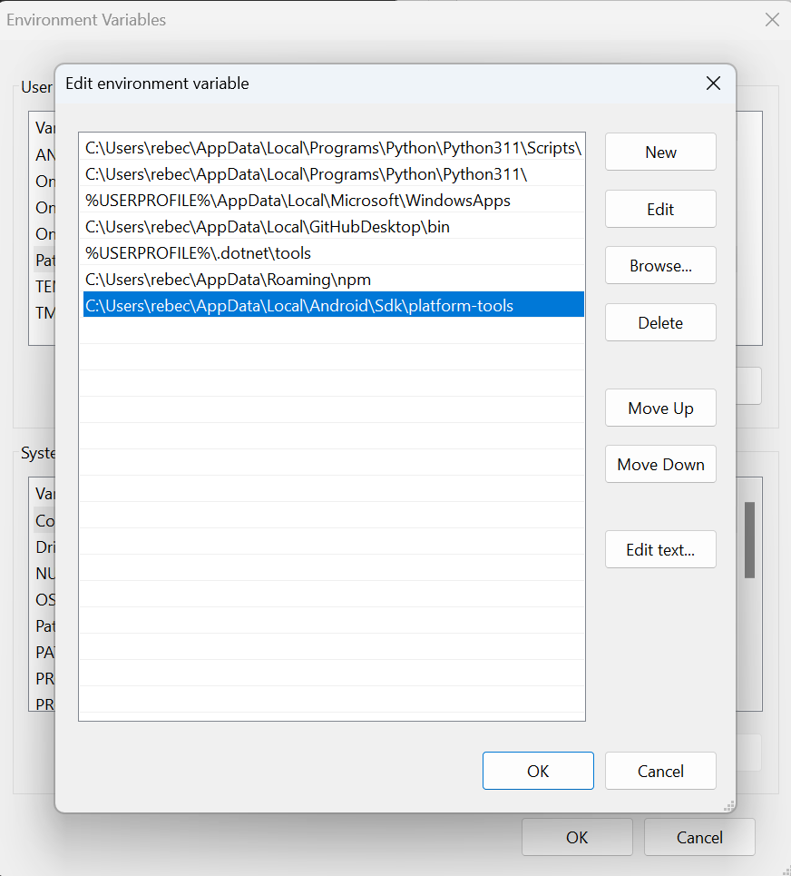

* Now that you have completed the Android Studio installation and configuration within the Android SDK, your Windows machine is ready for React Native development. You can now proceed with running your React Native projects on Android emulators or physical devices.

### Project Creation

1. Set up your Project folder.

* Firstly, create a dedicated project folder on your computer. It is recommended not to use OneDrive or Cloud storage for this purpose. For example, you can create a folder such as C:\cprg303 on your C Drive

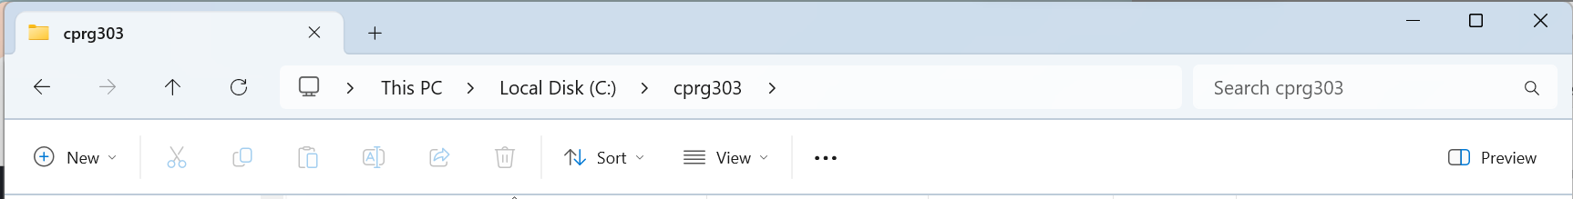

1. Open a Terminal or Command Prompt

* Type “cmd” in the file explorer to navigate to the project directory.

1. Create a New React Native Project

* Use the following command line to create a new React Native project. In this case, my project name is “IncredibleTodoListApp”.

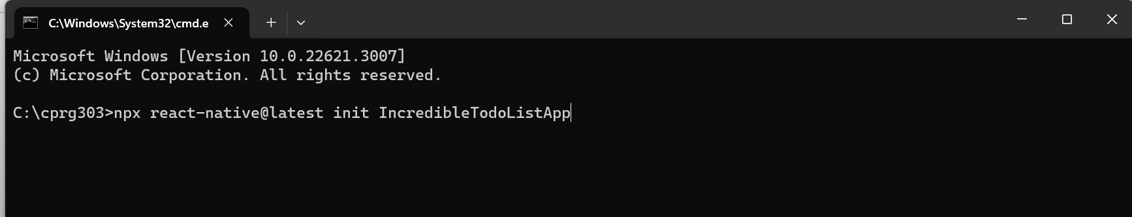

1. Open the Project in Visual Studio Code

* Open Visual Studio Code.
* Navigate to the folder you created.
* Click “Select Folder” and “Trust the author”

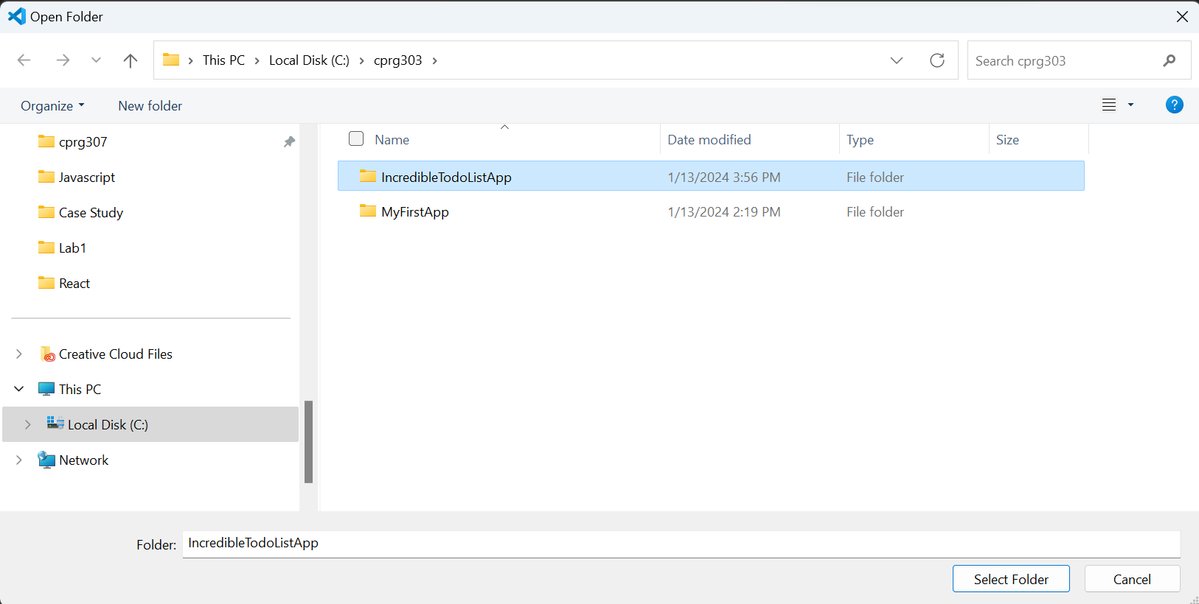

1. Adjust File Name to App.jsx

* Change the filename of “App.tsx” to “App.jsx”.
* Note: Ensure the code inside “App.jsx” is written in JavaScript.

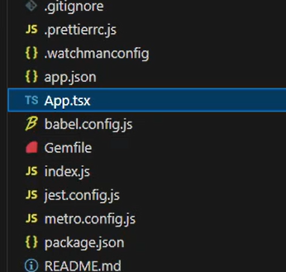

1. Start Coding

* Begin coding the Incredible Todo List App with Visual Studio Code.

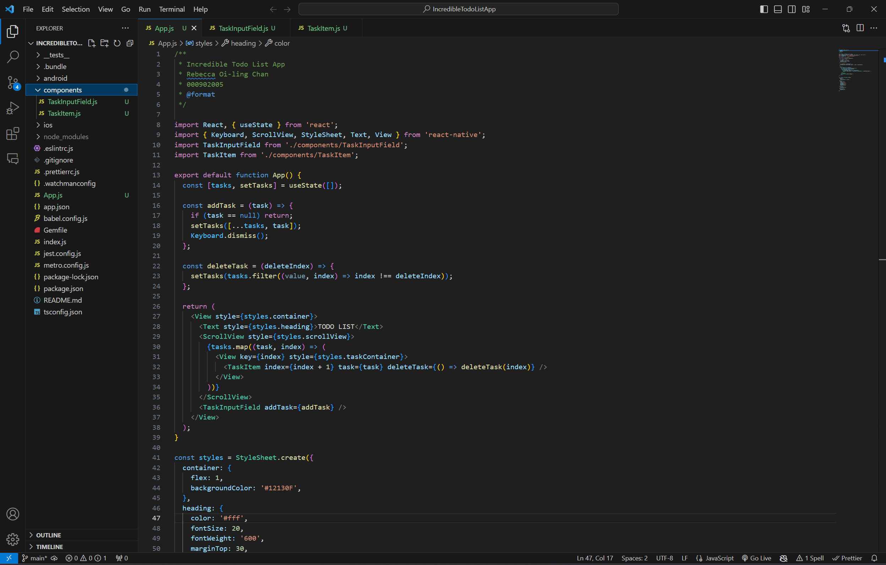

1. Set Up Device Emulator

* In the Welcome page of Android Studio, click “More Actions” and go to “Virtual Device Manager.”

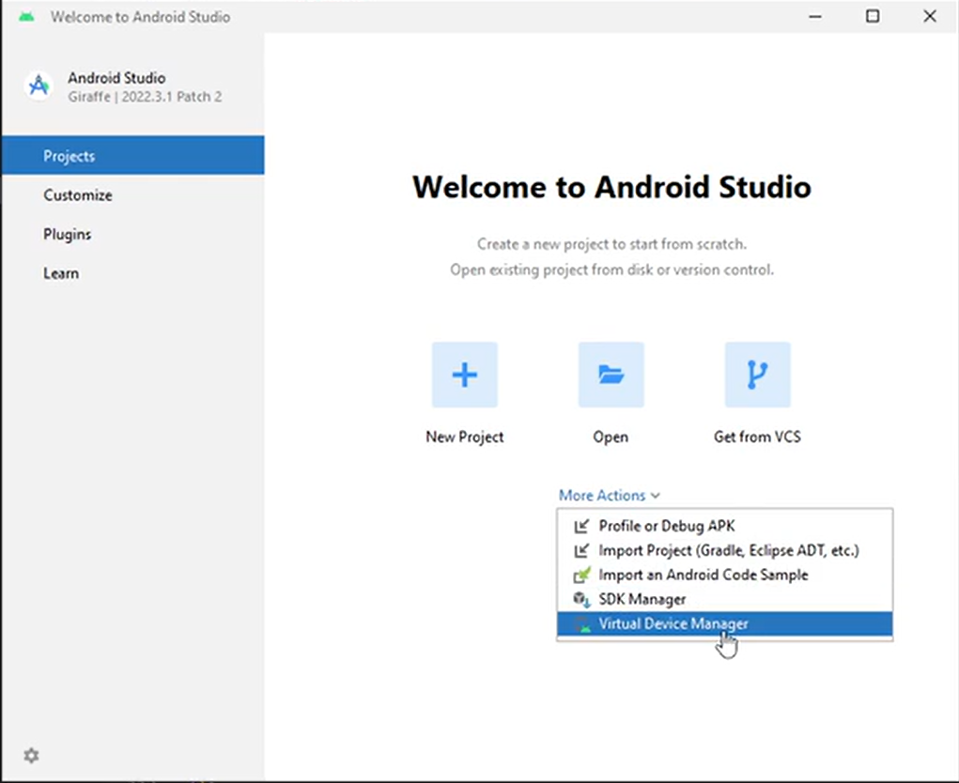

* Use Pixel 7 as your virtual device, ensuring it is set to “Phone” device.

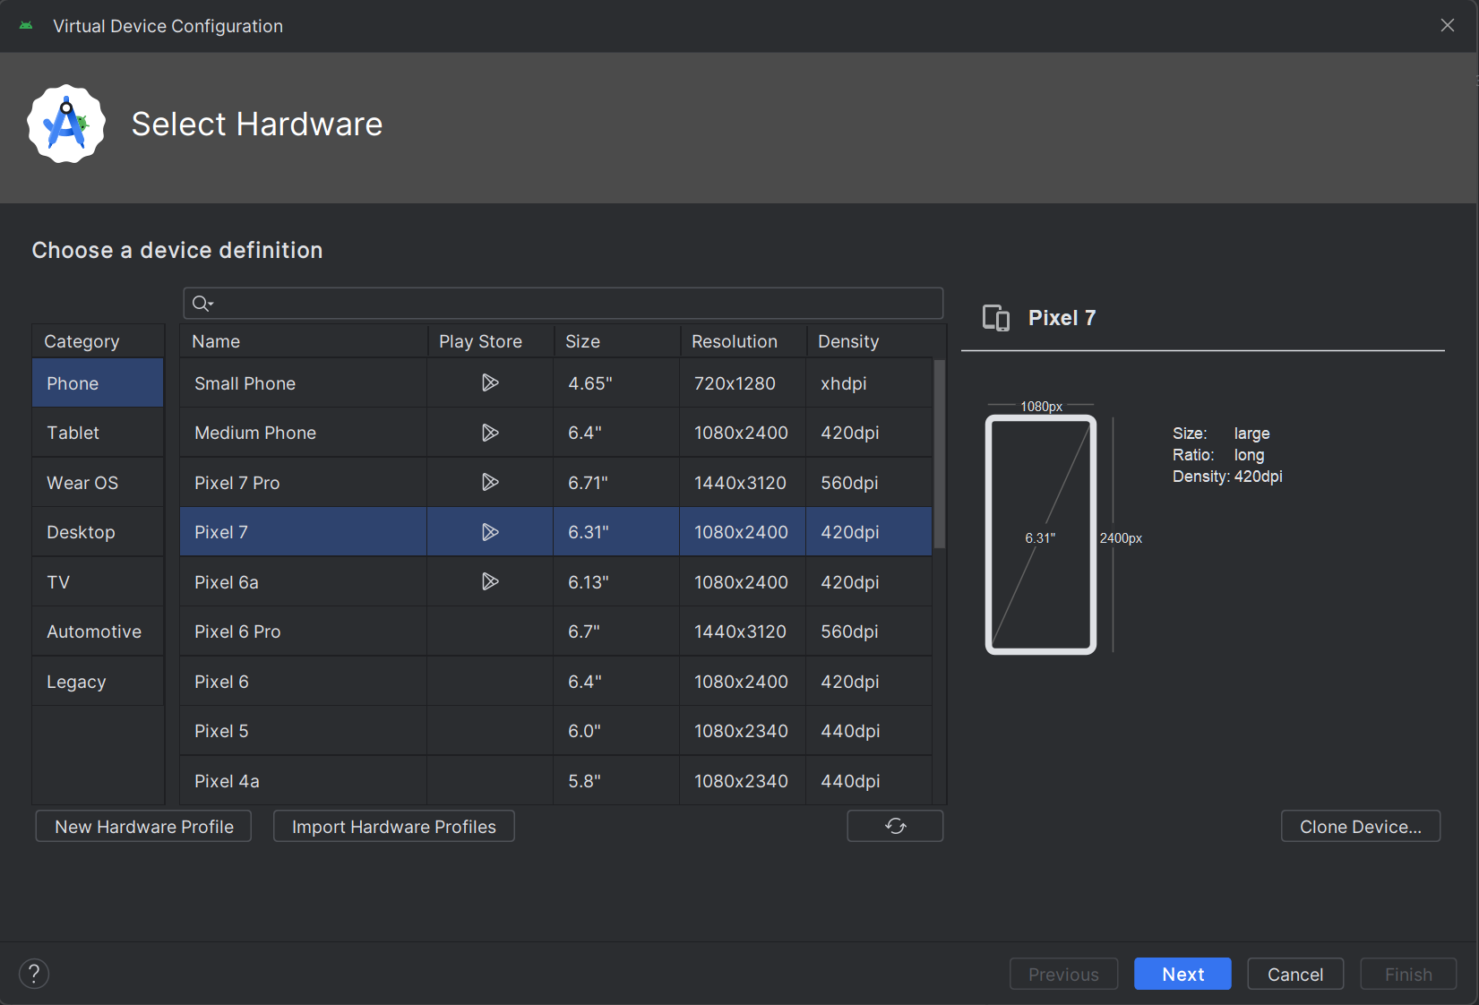

* Select “R” for system image and use Portrait for startup orientation.

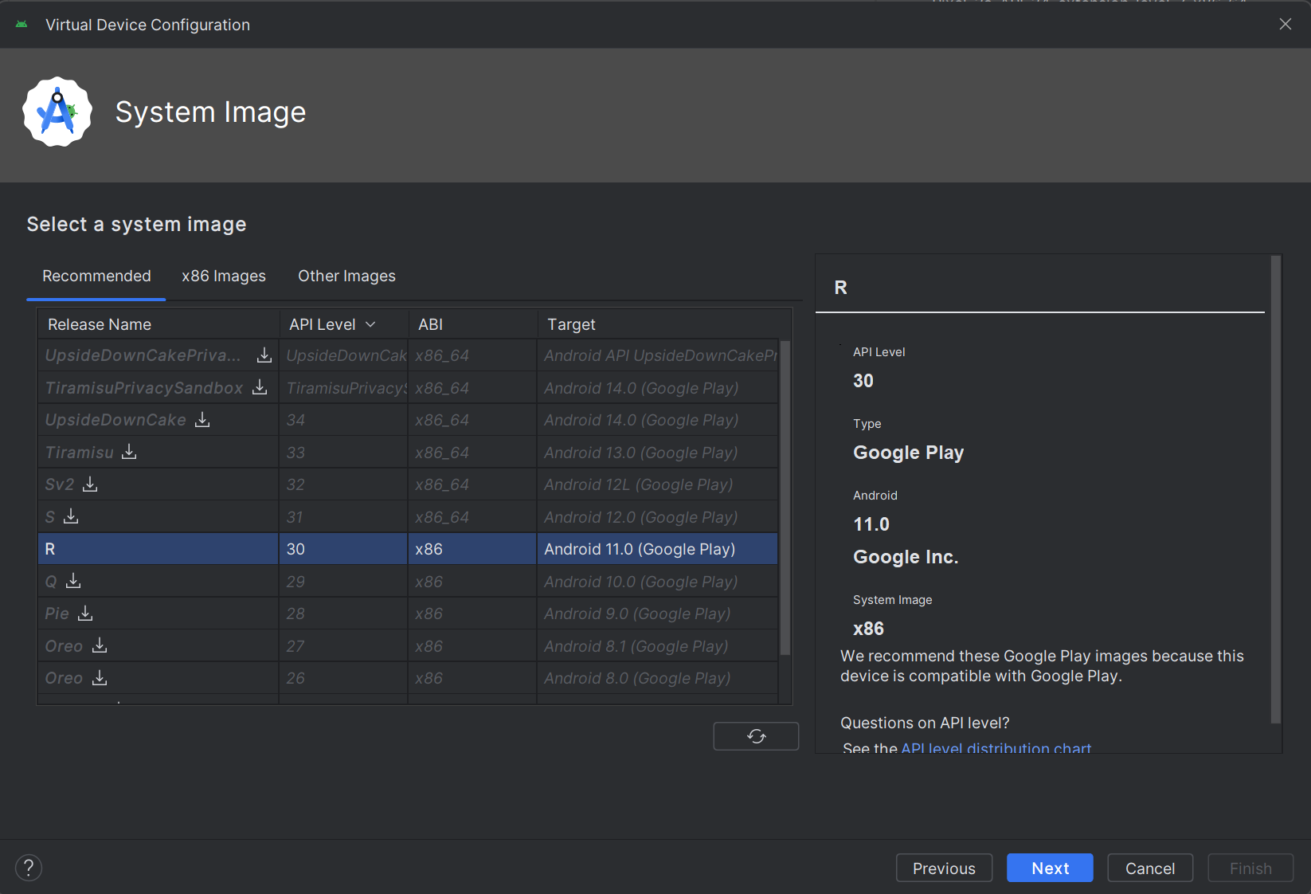

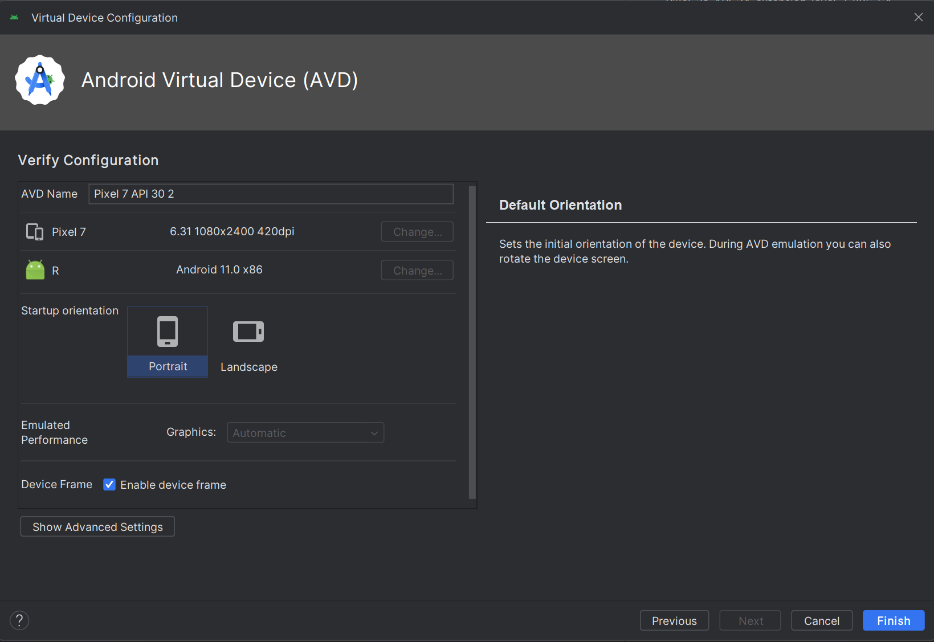

* Click “Finish” to complete the setup.

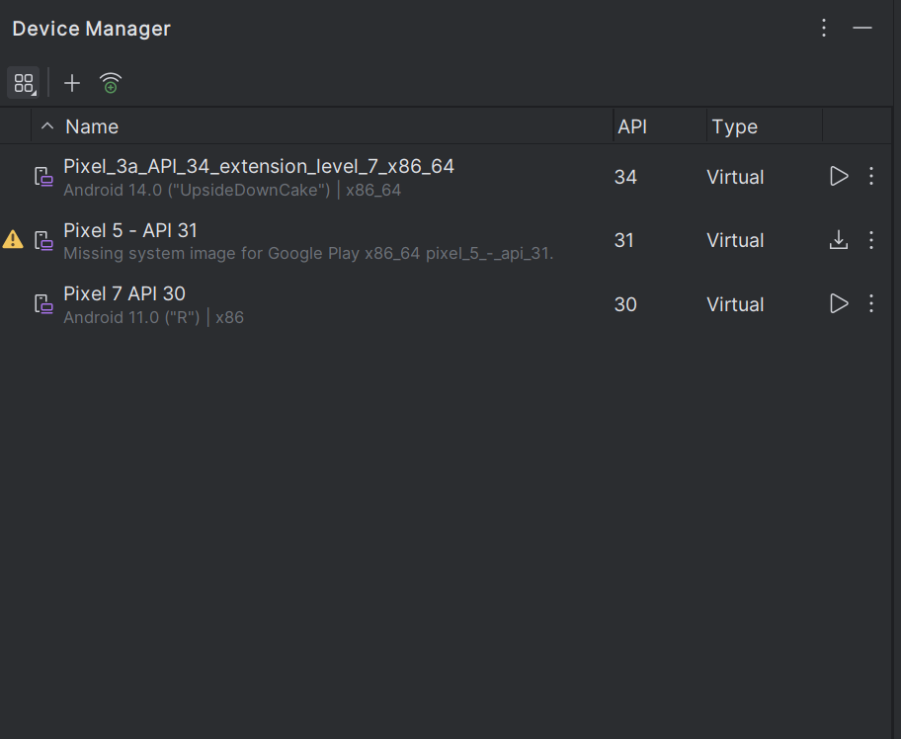

1. Virtual Emulator Setup

* The Pixel emulator has been set up.
* Note: During installation, you may encounter a Windows Defender Firewall prompt; click “Allow access”.
* The virtual emulator device is now ready for use.

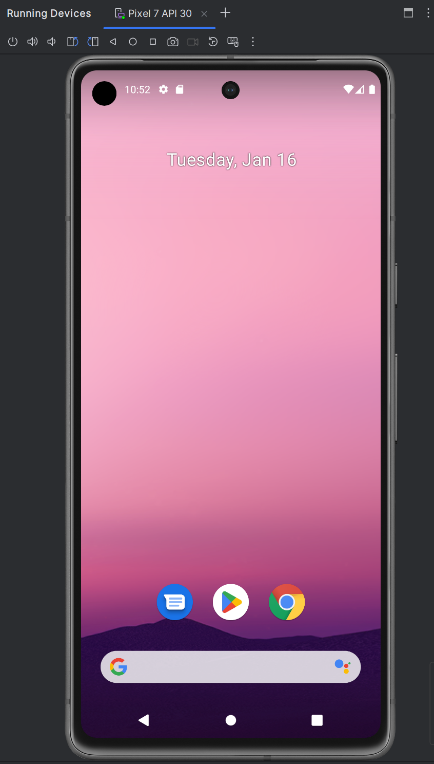

### Running the project

1. Open Android Studio:

* When running the project for the first time, open “Android Studio.”

1. Select Android File:

* In Android Studio, select the “Android” file in your project folder.

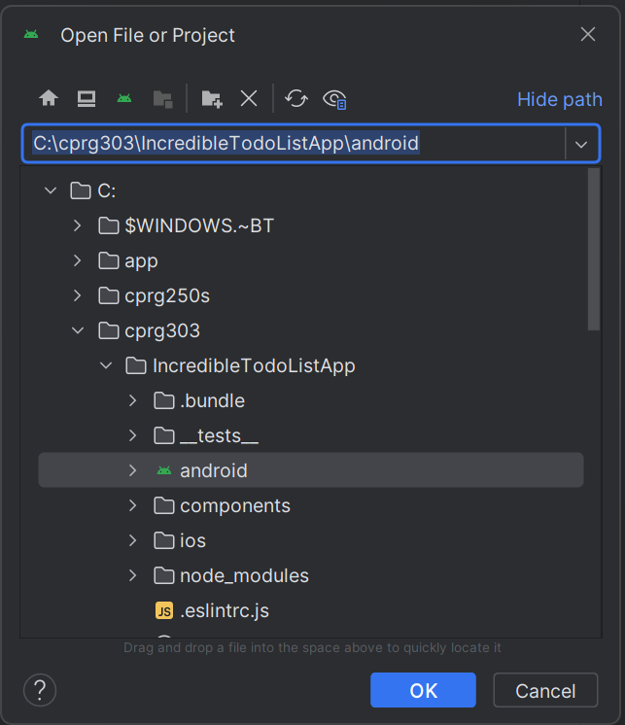

1. Wait for Program loading:

* Wait for the program to load. Ignore the background loading.

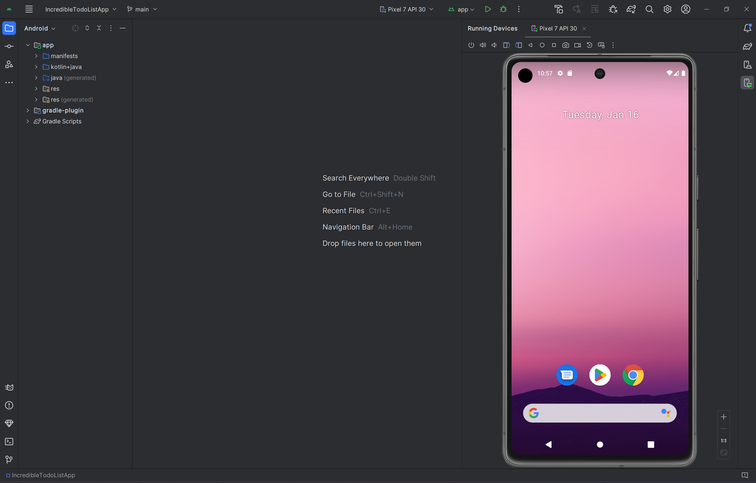

1. Build the Project:

* Click “Build” -> “Make Project” in the menu bar.
* Observe the build output in progress.

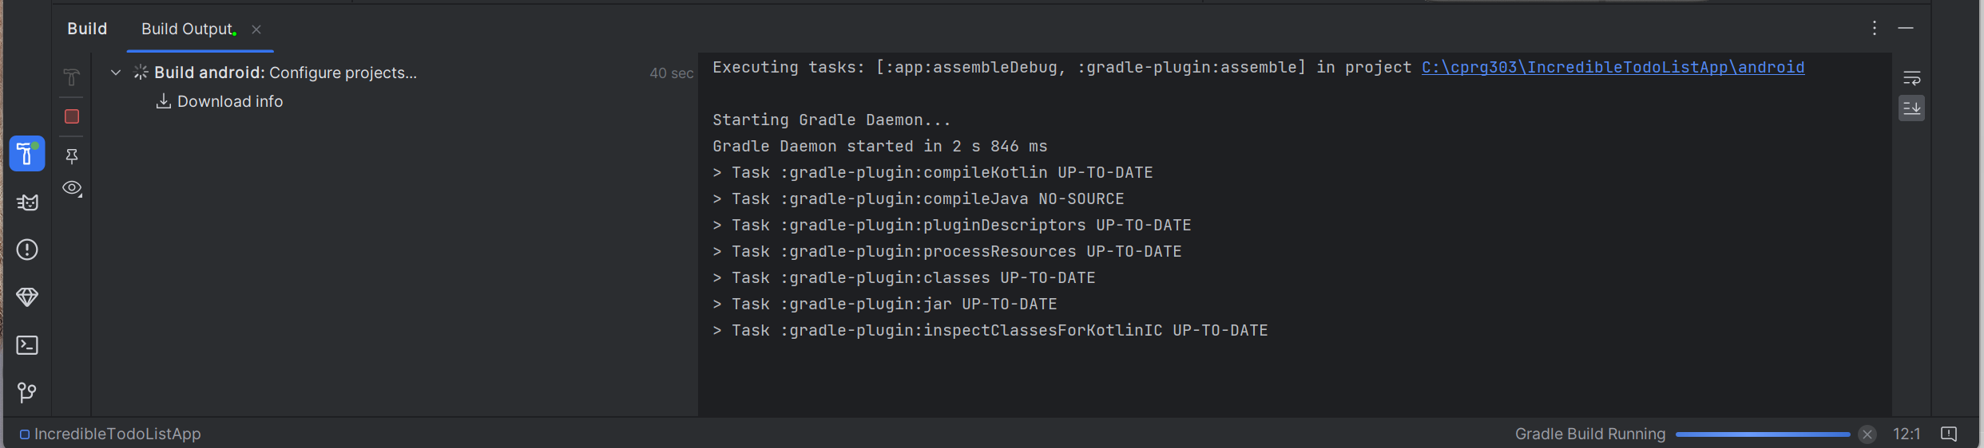

1. Build Successful:

* After the building is completed, “BUILD SUCCESSFIL” will be displayed.

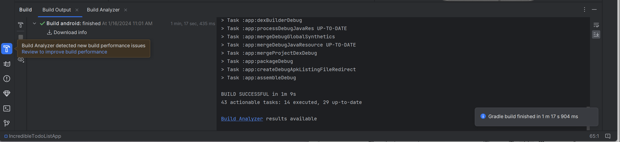

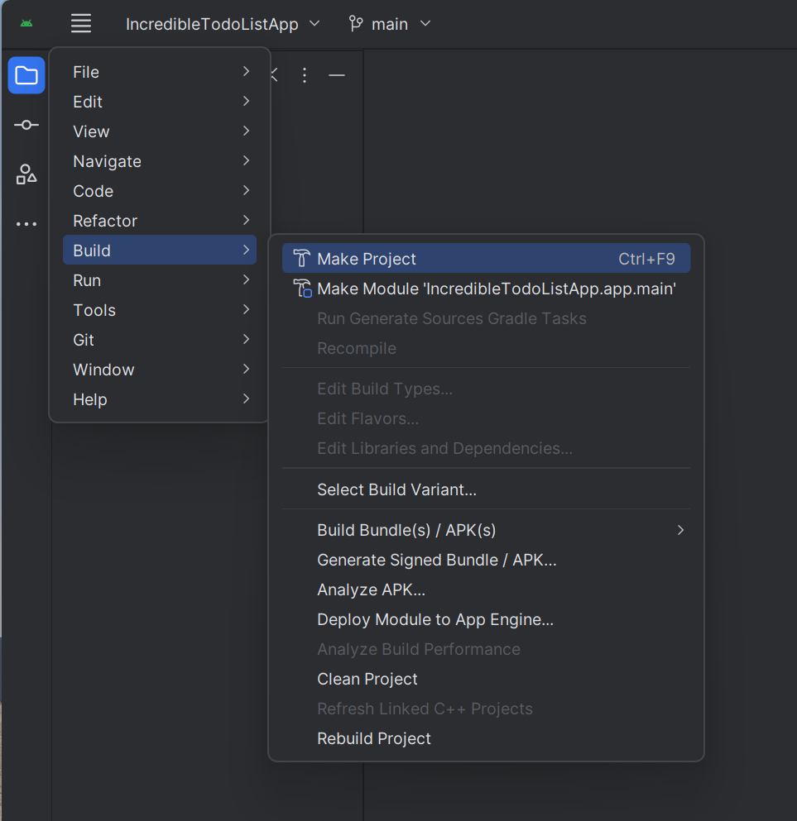

* After building the project, you may encounter an error message in the virtual emulator.

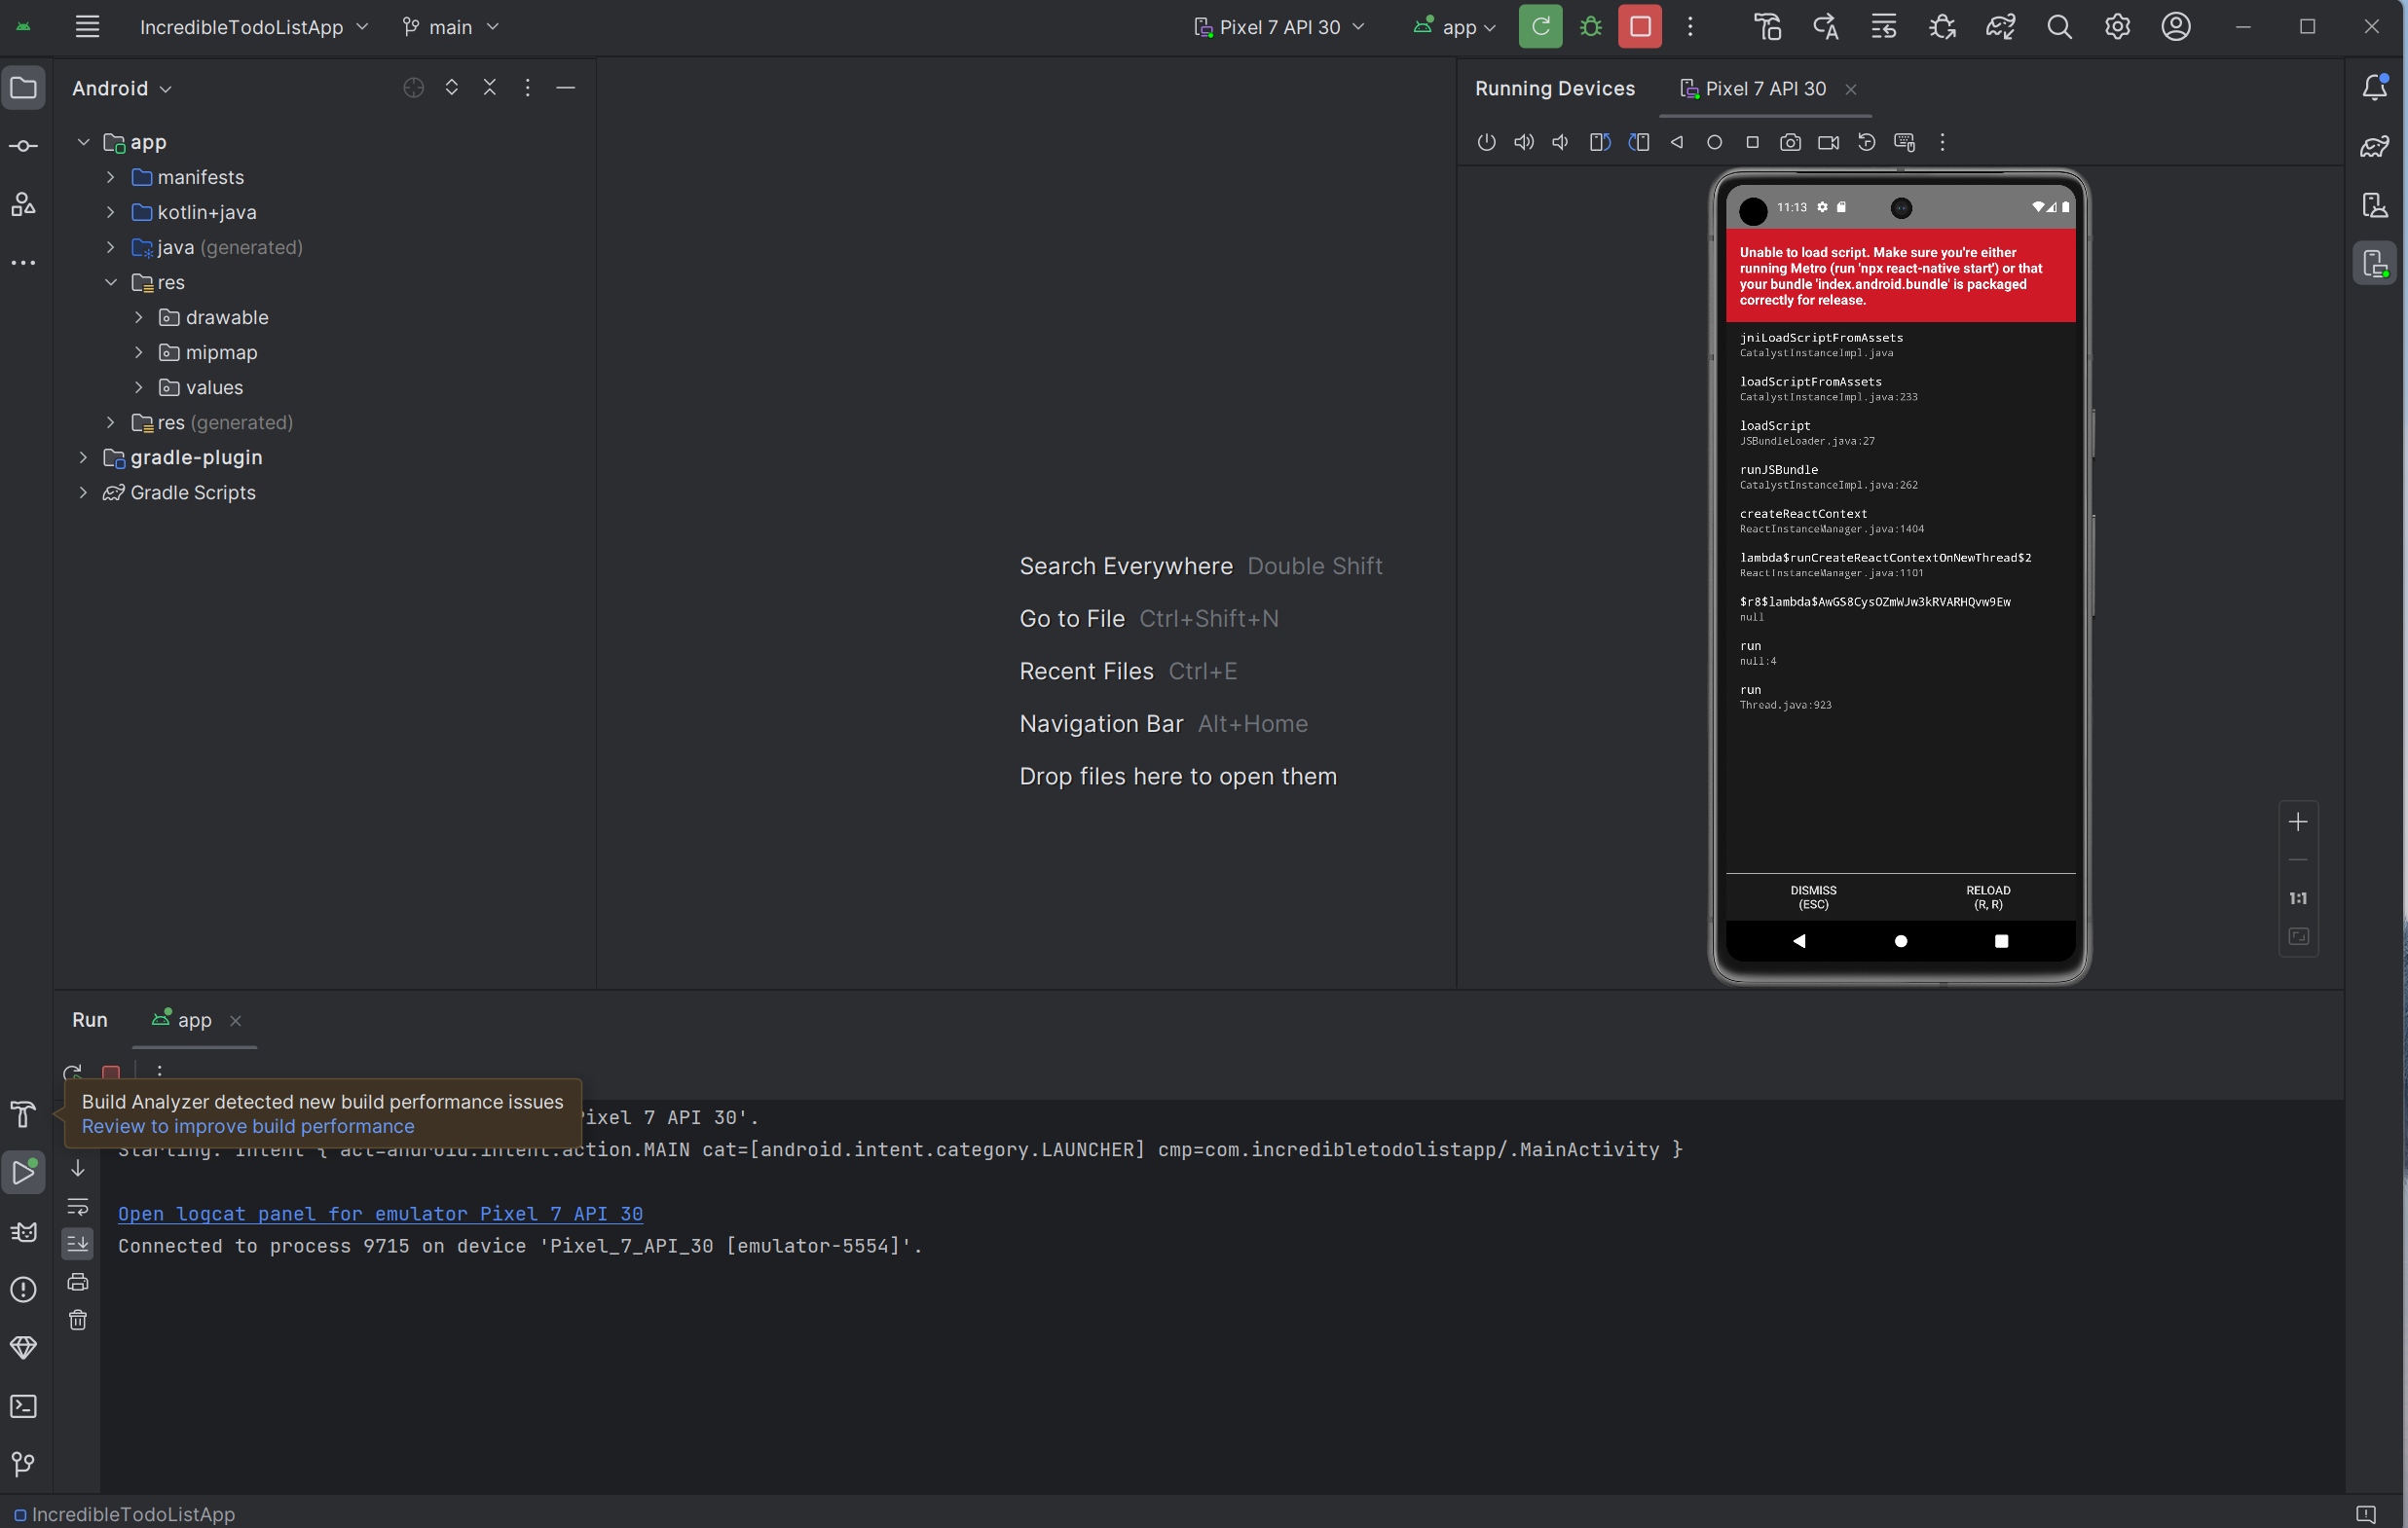

* Click “CMD” in the file explorer of the project directory.

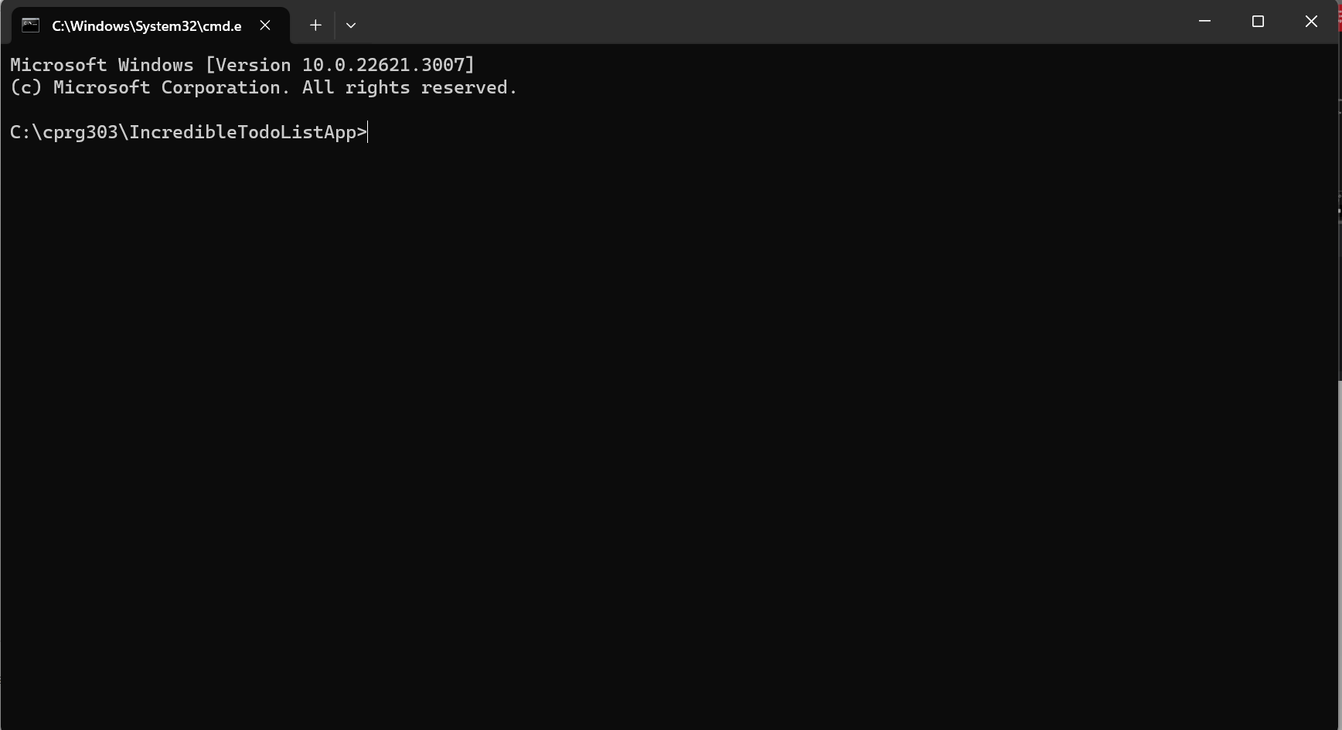

* Type the command – “npm run start.”

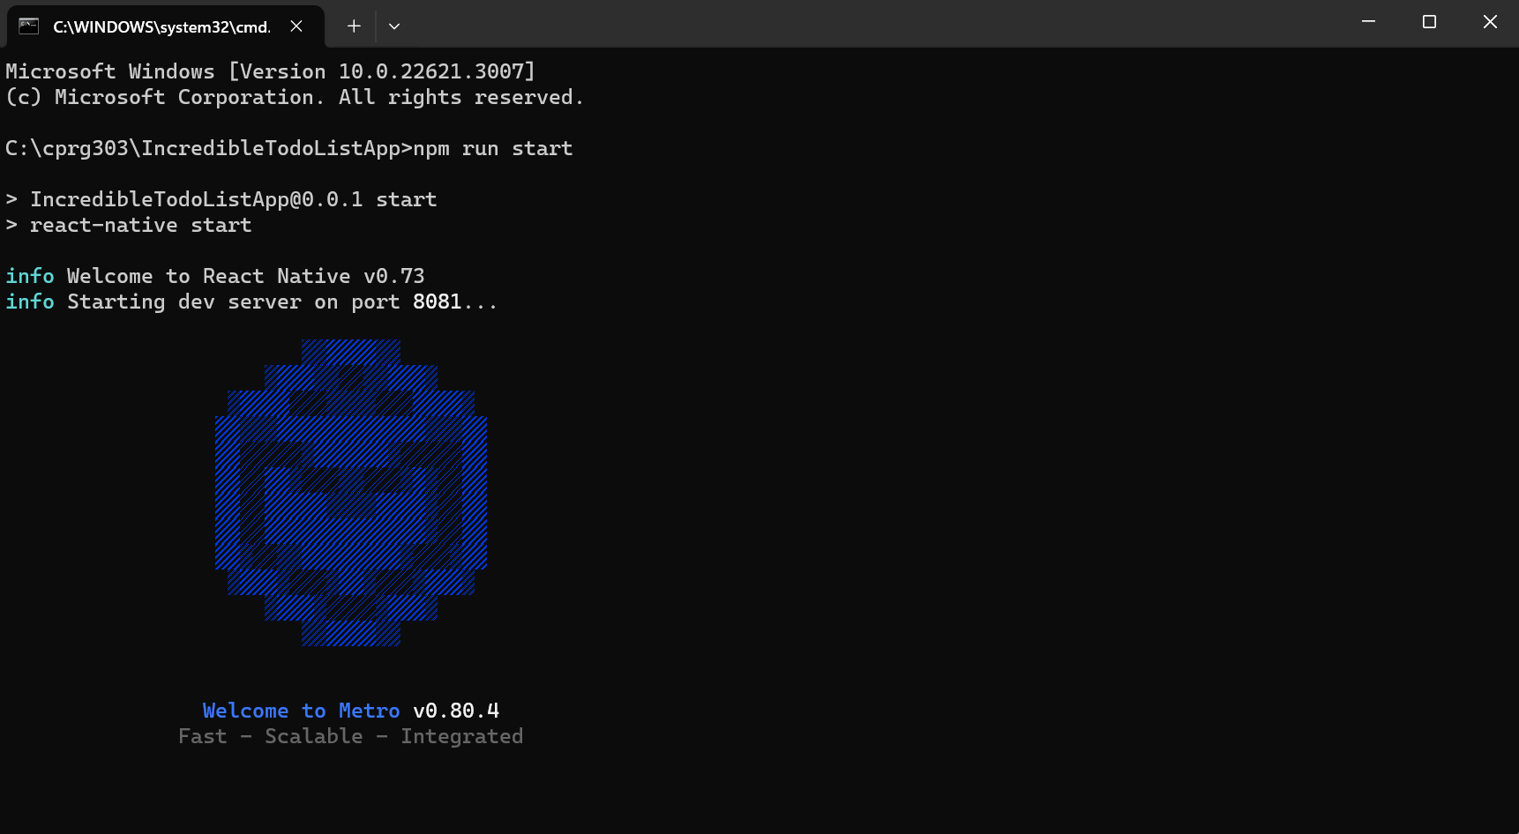

* Type “r” to reload the app.

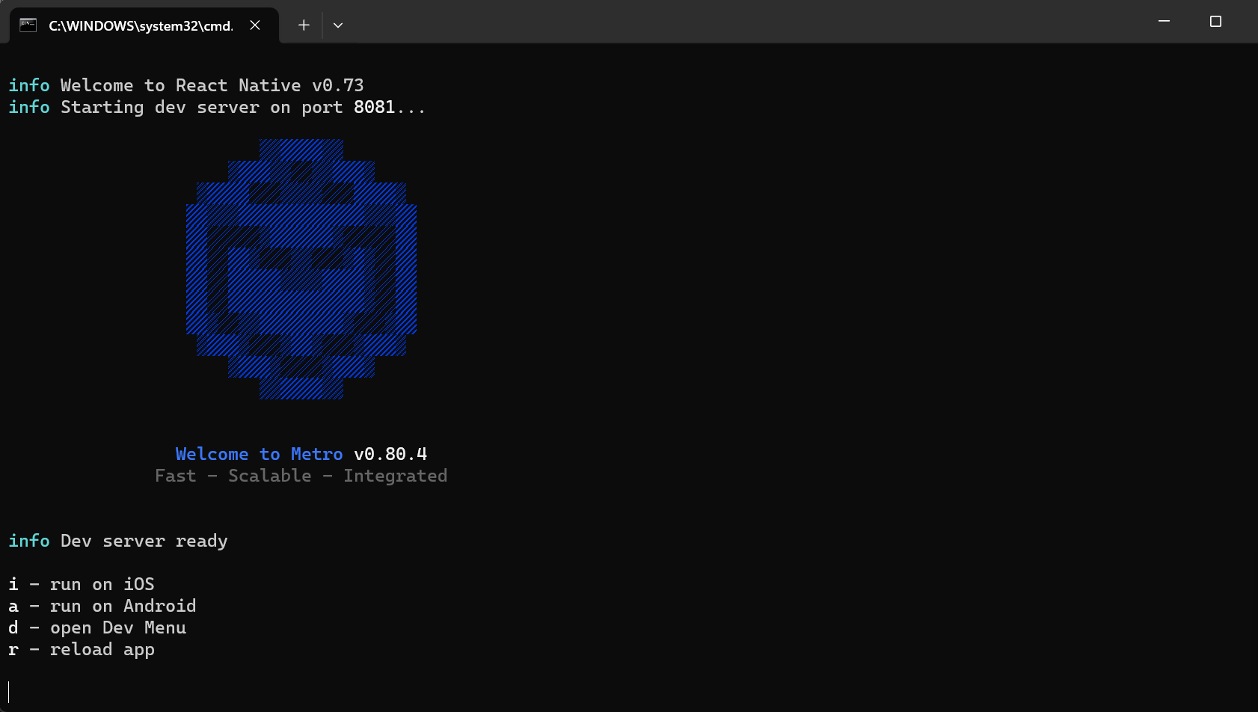

* Your project should now be displayed in the emulator.

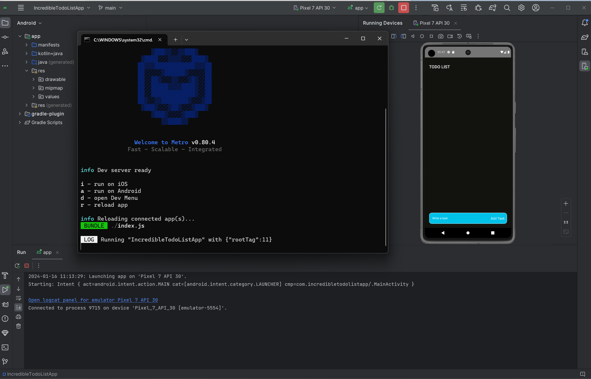

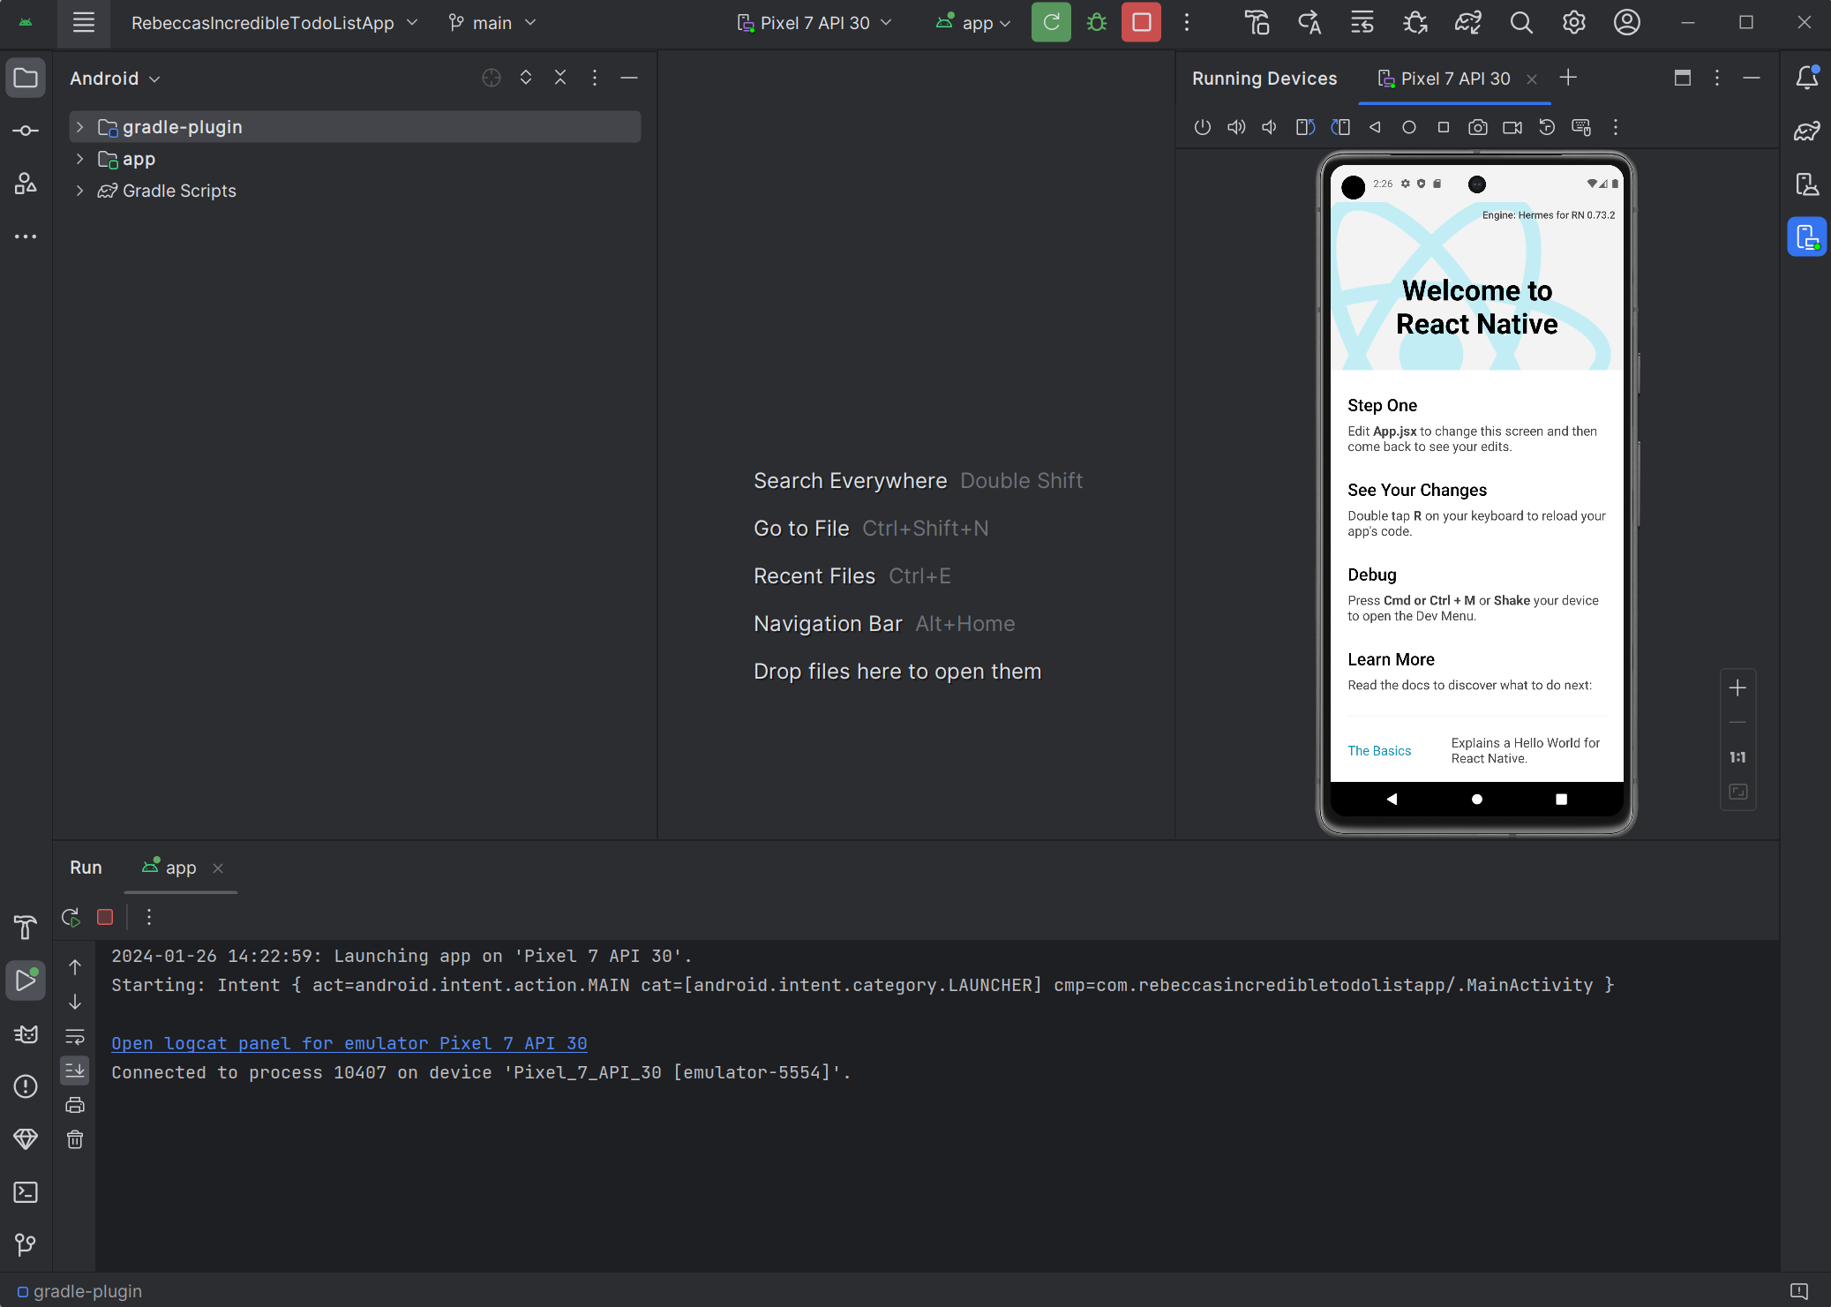

### Troubleshooting

React Native development may encounter common issues during setup and development. Here is a guide on how to troubleshoot and resolve some of these issues.

1. Check the React Native Documentation

* Visit <https://reactnative.dev/docs/environment-setup> for comprehensive information on environmental setup.

1. Update Node.js and npm

* Ensure you have the latest versions of Node.js and npm installed:

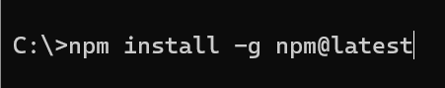

1. Clear Cache

* Clear the Metro bundler’s cache:

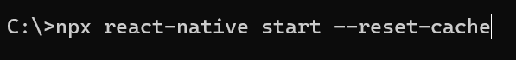

1. Build Error Fix

* If you encounter the error message "Failure: build failed with an exception" & "no matching variant of the project," follow these steps to resolve the issue:

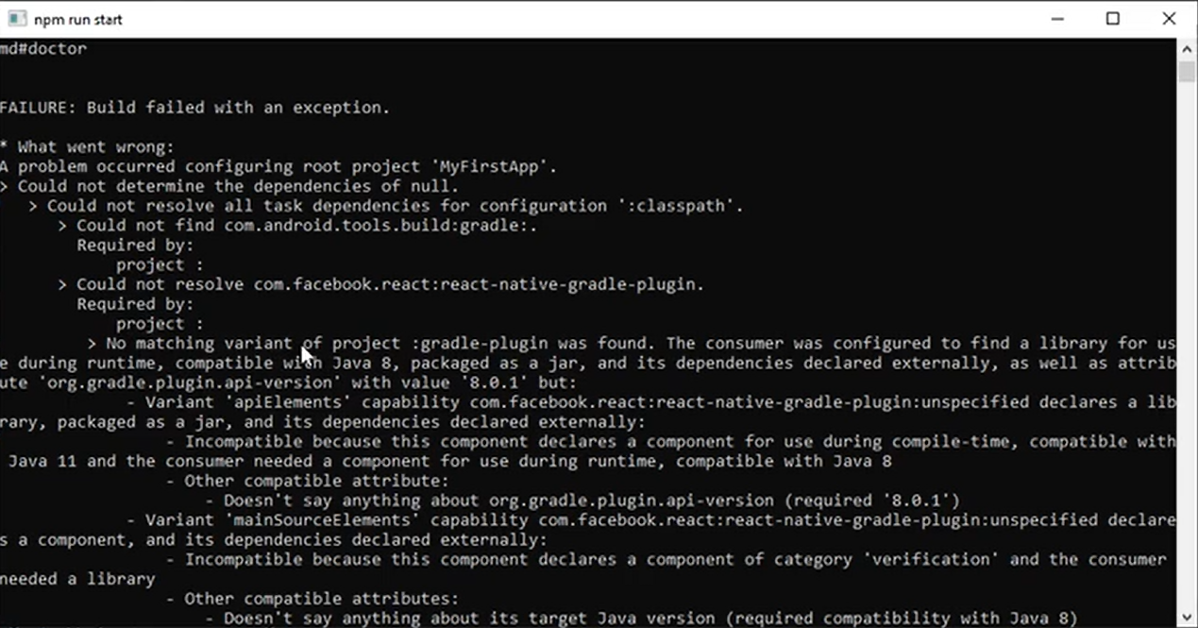

* Check Java JDK in PATH:
  + Navigate to “Edit environment variables for your account.”
  + Check if any Java JDK is added to the PATH. If so, delete all the Java JDK.
  + Add "Android Studio/jbr/bin" to the PATH if not included.

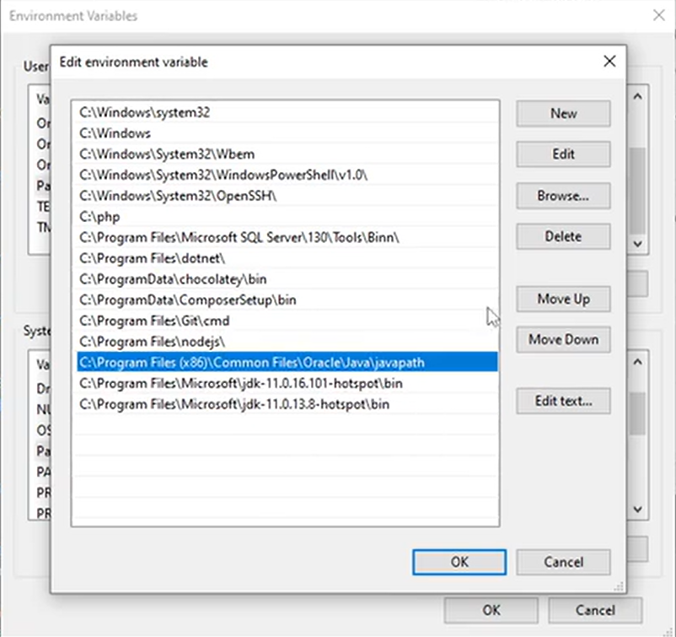

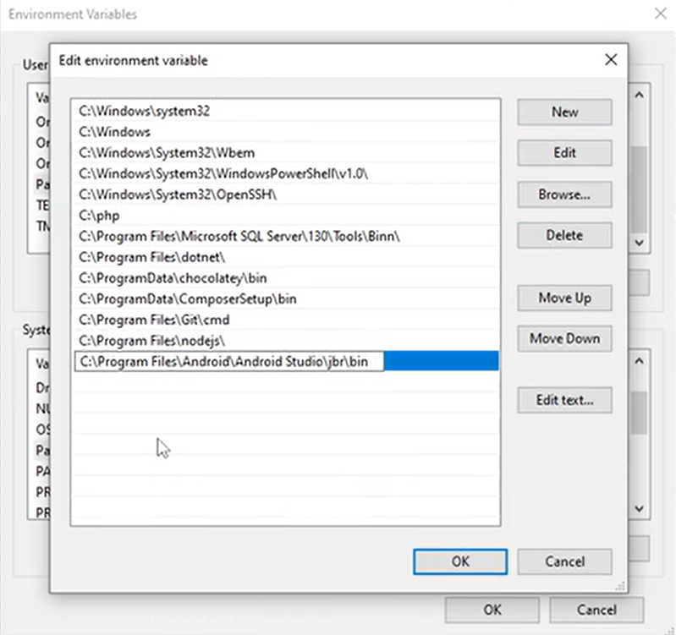

* After updating the PATH, close the error window without attempting to run the project.
* Re-run the project. Check if the issue is resolved. If not, proceed to the next step.
* If the problem persists, restart the computer, and open Android Studio and build the project again.

1. Troubleshooting Project Build Failure with React Native

If your code is correct, but you are experiencing project build failures, you can use the following steps:

* Run React Native Doctor:
  + Open your terminal and type “npx react-native doctor’.
  + React Native Doctor will analyze your project and provide information on any issues.
* Review Doctor’s report:
  + Examine the output from React Native Doctor. It will identify potential problems and suggest solutions.
* Example: Updating Android SDK.
  + From the image below, if the report indicates an outdated Android SDK version, it may suggest pressing “f” to fix the issue.
  + Follow the suggested prompts to update the Android SDK version.

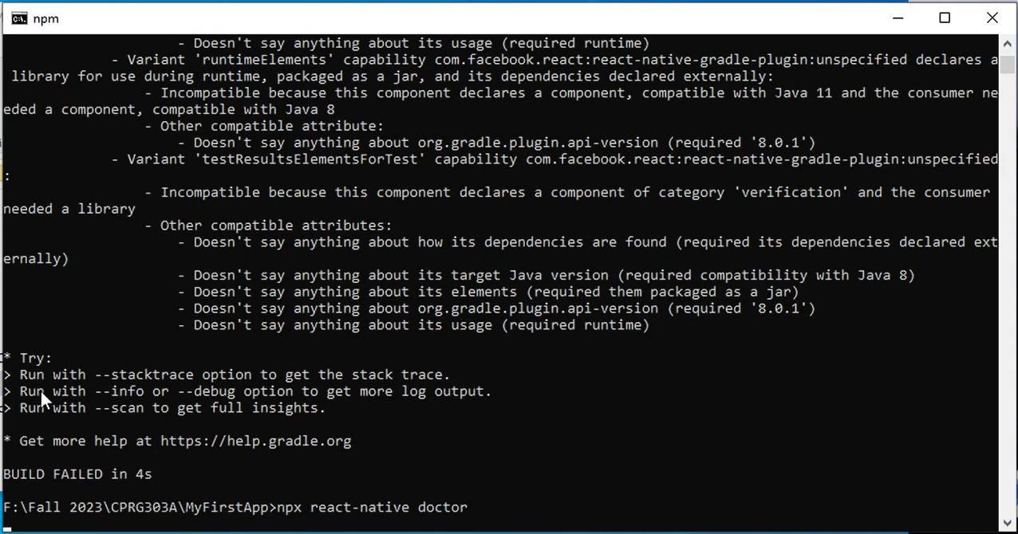

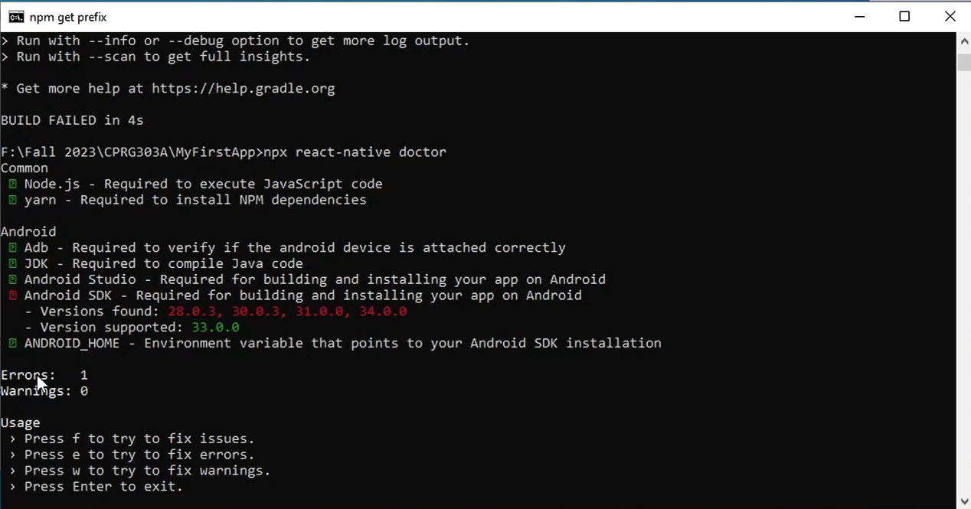

* Once you have followed the recommended steps, rerun the project build.

### Resources

Here are some additional resources and documentation to help you with React Native Development:

1. React Native Documentation –

https://reactnative.dev/docs/environment-setup

1. React Native GitHub Repository –

https://github.com/facebook/react-native

1. Stack Overflow – React Native - https://stackoverflow.com/questions/tagged/react-native